18. Assessment of the Skates Stock Complex in the Gulf of Alaska

Lee Cronin-Fine

November 2023

This report may be cited as:  
Cronin-Fine. L, 2023. Assessment of the Skates Stock Complex in the Gulf of Alaska. North Pacific Fishery Management Council, Anchorage, AK. Available from <https://www.npfmc.org/library/safe-reports/>

# Executive Summary

Directed fishing of skates is currently prohibited in the Gulf of Alaska (GOA). However, incidental catches of skates in other fisheries are sufficiently high enough that skates are considered to be “in the fishery” and require harvest specifications. The GOA skate complex is managed as three separate units: big skate (*Beringraja binoculata*), longnose skate (*Raja rhina*) and other skates. Big and Longnose skates have GOA-wide overfishing limits (OFLs) while the Acceptable Biological Catches (ABCs) are region specific (western [WGOA], central [CGOA], and eastern [EGOA]). Remaining skate species are managed as an “other skates” group, with GOA-wide harvest specifications. All GOA skates are managed under Tier 5, where OFL and ABC are based on survey biomass estimates and natural mortality rate (*M*).

## Summary of Changes in Assessment Inputs

*Changes in the input data:*

1. Updated catch estimates from 2022 and 2023 (2023 catch data as of October 16, 2023)
2. Biomass estimates from the 2023 GOA bottom trawl survey.

*Changes in the assessment methodology:*

No changes were made to the assessment methodology.

## Summary of Results

For 2024, the recommended maximum allowable ABC from the Tier 5 specifications for Big skate is 745 t in WGOA, 1,749 t in CGOA and 341 t in EGOA. The specifications for Longnose skate is 104 t in WGOA, 1,894 t in CGOA and 538 t in EGOA. The specifications for Other skates is 665 t. Reference values for all skates are summarized in the following tables, with the recommended ABC and OFL values for 2024 in bold. In the tables below W, C, and E indicate the Western, Central, and Eastern GOA regulatory regions.

| **Big skate (*Beringraja binoculata*)** | | | | | |
| --- | --- | --- | --- | --- | --- |
|  | | As estimated or *specified last* year for: | | As estimated or *recommended this* year for: | |
| **Quantity** | | 2022 | 2023 | **2024** | 2025 |
| *M* (natural mortality rate) | | 0.1 | 0.1 | 0.1 | 0.1 |
| Tier | | 5 | 5 | 5 | 5 |
| Biomass (t) | W | 7,882 | 7,882 | 9,934 | 9,934 |
| C | 19,756 | 19,756 | 23,326 | 23,326 |
| E | 10,581 | 10,581 | 4,545 | 4,545 |
| GOA Wide | 38,220 | 38,220 | 37,804 | 37,804 |
| *FOFL* | | 0.100 | 0.100 | 0.100 | 0.100 |
| *maxFABC* | | 0.075 | 0.075 | 0.075 | 0.075 |
| *FABC* | | 0.075 | 0.075 | 0.075 | 0.075 |
| OFL (t) | GOA Wide | 3,822 | 3,822 | **3,780** | 3,780 |
| *max*ABC (t) | W | 591 | 591 | 745 | 745 |
| C | 1,482 | 1,482 | 1,749 | 1,749 |
| E | 794 | 794 | 341 | 341 |
| ABC (t) | W | 591 | 591 | **745** | 745 |
| C | 1,482 | 1,482 | **1,749** | 1,749 |
| E | 794 | 794 | **341** | 341 |
|  |  | As determined *last* year for: | | As determined *this* year for: | |
| **Status** | | 2020 | 2021 | 2022 | 2023 |
| Overfishing? | | No | n/a | No | n/a |

| **Longnose skate (*Raja rhina*)** | | | | | |
| --- | --- | --- | --- | --- | --- |
|  | | As estimated or *specified last* year for: | | As estimated or *recommended this* year for: | |
| **Quantity** | | 2022 | 2023 | **2024** | 2025 |
| *M* (natural mortality rate) | | 0.1 | 0.1 | 0.1 | 0.1 |
| Tier | | 5 | 5 | 5 | 5 |
| Biomass (t) | W | 2,013 | 2,013 | 1,384 | 1,384 |
| C | 27,258 | 27,258 | 25,249 | 25,249 |
| E | 6,890 | 6,890 | 7,172 | 7,172 |
| GOA Wide | 36,162 | 36,162 | 33,804 | 33,804 |
| *FOFL* | | 0.100 | 0.100 | 0.100 | 0.100 |
| *maxFABC* | | 0.075 | 0.075 | 0.075 | 0.075 |
| *FABC* | | 0.075 | 0.075 | 0.075 | 0.075 |
| OFL (t) | GOA Wide | 3,616 | 3,616 | **3,380** | 3,380 |
| *max*ABC (t) | W | 151 | 151 | 104 | 104 |
| C | 2,044 | 2,044 | 1,894 | 1,894 |
| E | 517 | 517 | 538 | 538 |
| ABC (t) | W | 151 | 151 | **104** | 104 |
| C | 2,044 | 2,044 | **1,894** | 1,894 |
| E | 517 | 517 | **538** | 538 |
|  |  | As determined *last* year for: | | As determined *this* year for: | |
| **Status** | | 2020 | 2021 | 2022 | 2023 |
| Overfishing? | | No | n/a | No | n/a |

| **Other skates (*Bathyraja*)** | | | | |
| --- | --- | --- | --- | --- |
|  | As estimated or *specified last* year for: | | As estimated or *recommended this* year for: | |
| **Quantity** | 2022 | 2023 | **2024** | 2025 |
| *M* (natural mortality rate) | 0.1 | 0.1 | 0.1 | 0.1 |
| Tier | 5 | 5 | 5 | 5 |
| Biomass (t) | 13,114 | 13,114 | 8,869 | 8,869 |
| *FOFL* | 0.100 | 0.100 | 0.100 | 0.100 |
| *maxFABC* | 0.075 | 0.075 | 0.075 | 0.075 |
| *FABC* | 0.075 | 0.075 | 0.075 | 0.075 |
| OFL (t) | 1,311 | 1,311 | **887** | 887 |
| *max*ABC (t) | 984 | 984 | 665 | 665 |
| ABC (t) | 984 | 984 | **665** | 665 |
|  | As determined *last* year for: | | As determined *this* year for: | |
| **Status** | 2020 | 2021 | 2022 | 2023 |
| Overfishing? | No | n/a | No | n/a |

None of the three assessment groups experienced overfishing in 2022. This statement was determined by comparing the catch in 2022 to the associated OFL. For Big skate, the catch and OFL were 1,031 t and 3,822 t. For Longnose skate, the catch and OFL were 998 t and 3,616 t and for Other skates, the catch and OFL were 981 t and 1,311 t.

As of October 16, 2023, none of the assessments groups are experiencing overfishing; Big skate catch and OFL are 792 t and 3,822 t, Longnose skate catch and OFL are 1,055 t and 3,616 t and Other skate catch and OFL are 316 t and 1,311 t. As for 2023 ABCs, Big and Other skates have catches below their regional ABCs (Tables 18.1 and 18.3). Longnose skate has catches below their regional ABCs except for EGOA where the catch is larger than teh regional ABC (607 t catch and 517 t ABC) (Table 18.2).

## Responses to SSC and Plan Team Comments on Assessments in General

There were no comments related to this assessment from the SSC or Plan Team.

## Responses to SSC and Plan Team Comments Specific to this Assessment

There were no comments on this assessment from the SSC or Plan Team.

# Introduction

The full introduction can be found in the 2021 GOA skate assessment (Ormseth 2021). What follows is an abbreviation of the 2021 introduction.

#### Description, scientific names, and general distribution

Skates (family *Rajidae*) are flat-bodied cartilaginous fishes related to sharks. At least 15 species of skates in four genera (*Raja*, *Beringraja*, *Bathyraja*, and *Amblyraja*) are commonly found in shallow inshore waters to very deep benthic habitats in Alaskan waters (Eschmeyer *et al.* 1983; Stevenson *et al.* 2007). In the GOA, the most common skate species are the Longnose skate (*Raja rhina*) and the Big skate (*Beringraja binoculata*). The range of the Big skate extends from the Bering Sea to southern Baja California in depths ranging from 2 to 800 m. The Longnose skate has a similar range, from the southeastern Bering Sea to Baja California in 9 to 1,069 m depths (Love *et al.* 2005). While these two species have wide depth ranges, they are generally found in shallow waters in the GOA. The remaining 13 species, all from the family *Bathyraja*, are treated as one group called “Other skates” in this assessment since they are markedly less common. Within this group, the three most common species are the Aleutian skate (*B. aleutica*), the Alaska skate (*B. parmifera*), and the Bering skate (*B. interrupta*). The Aleutian skate ranges throughout the north Pacific from northern Japan to northern California and has been found in waters 16 to 1,602 m deep. The Alaska skate is restricted to higher latitudes from the Sea of Okhotsk to the eastern Gulf of Alaska in depths from 17-392 m (Stevenson *et al.* 2007). The range of the Bering skate is difficult to determine at this time as it may actually be a complex of species, with each individual species occupying a different part of its general range from the western Bering Sea to southern California (Love *et al.* 2005; Stevenson *et al.* 2007).

The species within the skate assessment occupy different habitats and regions within the GOA groundfish Fishery Management Plan. This assessment distinguishs habitat primarily by depth for GOA skates. The highest biomass of skates is found in the shallowest continental shelf waters of less than 100-m depth and is normally dominated by Big skates, while Longnose skates are the most abundant species in the 101-200 m depth zone. Skates in the *Bathyraja* genus are dominant in the deeper waters extending from 200 to 1000 m or more in depth. These depth distributions are reflected in the spatial distribution of GOA skates. Big skates are located inshore and are most abundant in the central and western GOA. Longnose skates are located further offshore and are relatively less abundant in the western GOA.

#### Life history and stock structure

Skate life cycles are similar to sharks, with relatively low fecundity, slow growth to large body sizes, and dependence of population stability on high survival rates of a few well-developed offspring (Moyle and Cech 1996). Sharks and skates in general have been classified as “equilibrium” life history strategists, with very low intrinsic rates of population increase implying that sustainable harvest is possible only at very low to moderate fishing mortality rates (King and McFarlane 2003). Within this general equilibrium life history strategy, there can still be considerable variability between skate species in terms of life history parameters (Walker and Hislop 1998).

While smaller-sized skate species have been observed to be somewhat more productive, large skate species with late maturation (11+ years) are most vulnerable to heavy fishing pressure (Walker and Hislop 1998; Frisk *et al.* 2001, 2002). Several studies have explored the effects of fishing on a variety of skate species to determine which life-history traits and stages are the most important for management. Age and size at maturity and adult size/longevity appear to be more important predictors of resilience to fishing pressure than fecundity or egg survival. Skate species with the largest adult body sizes (and the empirically related large size/age at maturity, Frisk *et al.* (2001)) were least resilient to high fishing mortality rates. This is most often attributed to the long juvenile stage during which relatively large yet immature skates are exposed to fishing mortality. After an extensive review of population information for many elasmobranch species, Frisk *et al.* (2001) recommended that precautionary management be implemented especially for the conservation of large species.

# Fishery

A full description of the fishery history can be found in the 2021 GOA skate assessment (Ormseth 2021). What follows are any recent significant changes to the fishery or management measures.

*Directed fishery, bycatch, and discards in federal waters*

There has been no directed fishery for skates since 2005. There are incidental catches of skate in other fisheries such as arrowtooth flounder and Pacific Cod. In January 2016, the Alaska Regional Office indefinitely reduced the maximum retainable amount of all skates from 20% to 5%.

*Management units*

Since 2005, Big skates and Longnose skates have had separate ABCs and TACs for WGOA, CGOA and EGOA to address concerns about disproportionate harvest of skates. Other skates continue to be managed as a Gulf-wide species complex because they are not generally retained and are difficult to distinguish at the species level. See Tables 18.1, 18.2 and 18.3 for a time series of the total catch, TAC, ABC and OFL for the three assessment groups.

# Data

## Fishery

*Catch*

See Tables 18.1, 18.2 and 18.3 for a time series of the total catch for the three assessment groups from 2005 to 2023. The 2023 catch data are incomplete. They were last updated on October 16, 2023.

*Age and Size Composition*

Fishery observers have been collecting length composition data since 2009. However, they are not used to determine stock status for any of the three assessment groups.

## Survey

There are several potential indices of skate abundance in the Gulf of Alaska, including longline and trawl surveys. For this assessment, only the AFSC bottom trawl surveys 1984-2019 is used when determining harvest recommendations and biomass estimates since it has the most comprehensive spatial coverage of the available surveys. Information on the other potential indices can be found in the 2021 GOA skate assessment (Ormseth 2021).

#### AFSC bottom trawl survey biomass estimates

The AFSC bottom trawl survey was a triennial survey until 2003 when it became biannual. Biomass estimates from the survey for all three assessments groups can be found in Table 18.4. The survey biomass estimates for Big and Longnose skates has been pretty stable for the past five years with little evidence of the population increasing or decreasing (Figure 18-1). The 2023 survey biomass estimate for Big skate estimate increased by 15% while the Longnose survey biomass estimate decreased by 9% when compared to the previous (2021) survey biomass estimate. Both are well within the 2021 survey biomass estimated confidence intervals. As for Other skates, their survey biomass estimates declining from 2013 to 2019. It has remained around the same low level ever since. The 2023 survey biomass estimate (8,617 t) is the lowest value since 1993 (Figure 18-1).

The GOA regional survey biomass estimates for Big skate are in Table 18.5. These survey estimates have larger coefficient of variance (CV) when compared to the GOA-wide estimates. Big skate are most abundant in CGOA. The survey biomass estimates in CGOA and WGOA appears relatively stable though there is a lot of variability. The EGOA survey biomass estimates have been declining since 2019 with the lowest survey biomass estimate (3,258 t) occurring in 2023 (Figure 18-2). It is difficult to determine the severity of this decline given the large CVs.

The GOA regional survey biomass estimates for Longnose skate are in Table 18.6. These survey estimates also have larger CVs when compared to the GOA-wide estimates. Longnose skate are the most abundant in CGOA. The survey biomass estimates in all three areas appear to be relatively stable thought there is a lot of variability (Figure 18-3).

# Analytical approach

All three GOA skates assessment groups are Tier 5 stocks that require an estimated biomass time series. A random effects (RE) model within the REMA model R package (Sullivan *et al.* 2022) was used to produce biomass estimates suitable for harvest recommendations. The REMA model is a generalized random effects model for fitting biomass estimates with the option of including multiple survey strata. For each assessment group (Big, Longnose, and Other), a GOA-wide RE model was used to determine the recommended OFL and GOA-wide ABC. For Big and Longnose skates, a regional-specific (Western, Central and Eastern) REMA model was run to determine the proportion of the GOA-wide biomass within each region. The biomass in each region was determined by multiplying the proportion, determined by the region specific REMA model, by the GOA-wide biomass, determined by GOA-wide RE model. The confidence intervals for the region specific biomass was determined by assuming the standard error of the log of the proportion by region multiplied by the GOA-wide biomass was equivalent to the standard error of the log of the region specific biomass determined by the region specific REMA model.

## Parameter Estimates

*Natural Mortality (M)*

An *M* value of 0.1 was used for all three GOA skate assessment groups.

# Results

For all three assessment groups, the GOA-wide projected biomass for 2024 was lower than the projected biomass for 2023 from last years assessment. For Big and Longnose skates, the decrease was small (38,220 t to 37,804 t, a 1.09% decline for Big skate and 36,162 t to 33,804 t, a 6.52% decline for Longnose skate). The decline in Other skates was the largest (13,114 t to 8,869 t, a 32.37% decline for Other skates). Other skates had a large decline from 2013 to 2019 and have remained low ever since. It is difficult to say whether Other skates biomass is still declining however the 2023 estimate (8,869 t) is the lowest since 1995.

The region specific biomass estimates for Big and Longnose skates can be used to determine whether changes to the population biomass are GOA-wide or region specific. For Big skate, the WGOA and CGOA projected biomass for 2024 was higher than the their projected biomass for 2023 from last years assessment (7,882 t to 9,934 t, a 26.03% increase for WGOA and 19,756 t to 23,326 t, a 18.07% increase for CGOA). The only area that had a decrease was EGOA (10,581 t to 4,545 t, a 57.05% decline). EGOA has the smallest estimated biomass out of all three areas and is at its lowest estimated value since 1990. The exploitation rate (catch/biomass) for EGOA has been relatively high for the past four years when compared to the entire exploitation rate time series except for 2006 (Figure 18-6). However, the total catch of Big skate in EGOA has remained below the TAC since at least 2005 (Figure 18-5).

As for the Longnose skate region specific biomass estimates, they all declined except for EGOA (2,013 t to 1,384 t, a 31.25% decrease for WGOA, 27,258 t to 25,249 t, a 7.37% decrease for CGOA and 6,890 t to 7,172 t, a 4.09% increase for EGOA). The largest decline occurred in WGOA which had the smallest estimated biomass. It is difficult to determine if this decrease is a sign of a declining population in WGOA or if this is just variability in the survey biomass estimates, which has wide confidence intervals, or natural annual variability (Figure 18-3). It is also important to point out that, as of October 16, 2023, the catch in EGOA is above the ABC (Figure 18-5). This is the first time this has happened since at least 2005. However, the catch in EGOA has been close to the ABC for the past two years. Also, for the past two years the exploitation rate in EGOA has been high when compared to the entire exploitation rate time series. The highest exploitation rate occurred in 2023 (Figure 18-6).

## Exploitation Rates

The GOA-wide exploitation rates have alot of inter-annual variability (Figure 18-7). Other skates tend to have the highest exploitation rates with considerable inter-annual variability (values ranging from 0.094 - 0.035 since 2016). Big and Longnose skates have had low exploitation rates with values below 0.04 since 2017. The area specific exploitation rates for Big skate show a declining trend for CGOA and WGOA while EGOA has been increasing since 2019. In 2023, all three areas have exploitation rates below 0.03, as of October 16, 2023 (Figure 18-6). As for Longnose skate area specific exploitation rates, CGOA has been declining since 2013 with a 2023 value of 0.015, EGOA has been increasing since 2018 with a 2023 value of 0.085 and WGOA has alot of interannual variability with a 2023 value of 0.042. All the 2023 Longnose skate area specific exploitation rate values are as of October 16, 2023 (Figure 18-6).

## Harvest Recommendations

*Amendment 56 Reference Points*

All three skate assessment groups are a Tier 5 stock. Therefore harvest recommendations are based on an estimated biomass time series (*Best*). The harvest recommendations are calculating as follows; *FOFL = M*, *OFL = FOFL* * *Best* and *ABCmax = 0.75* * *OFL* where *ABCmax* is the maximum permissible ABC.

*Specification of OFL and Maximum Permissible ABC*  
Big skate  
The REMA model biomass estimate of Big skate for 2024 is 37,804 t, therefore the OFL = 3,780 t and *ABCmax* = 2,835 t. The regional biomass estimates are 9,934 t (26.3%) for the WGOA; 23,326 t (61.7%) for the CGOA; and 4,545 t (12%) for the EGOA. The resulting region-specific ABCs are 745 t for the WGOA; 1,749 t for the CGOA; and 341 t for the EGOA.

Longnose skate  
The REMA model biomass estimate of Longnose skate for 2024 is 33,804 t, therefore the OFL = 3,380 t and *ABCmax* = 2,536 t. The regional biomass estimates are 1,384 t (4.1%) for the WGOA; 25,249 t (74.7%) for the CGOA; and 7,172 t (21.2%) for the EGOA. The resulting region-specific ABCs are 104 t for the WGOA; 1,894 t for the CGOA; and 538 t for the EGOA.

Other skates  
The REMA model estimate of Other skate biomass for 2024 is 8,869 t, therefore the OFL = 887 t and *ABCmax* = 665 t. The Other skate ABC is not apportioned among regions.

*Status Determination*  
None of the three assessment groups experienced overfishing in 2022. This statement was determined by comparing the catch in 2022 to the associated OFL. For Big skate, the catch and OFL were 1,031 t and 3,822 t. For Longnose skate, the catch and OFL were 998 t and 3,616 t and for Other skates, the catch and OFL were 981 t and 1,311 t.

## Risk Table and ABC recommendation

The following template is used to complete the risk table:

|  | ***Assessment-related considerations*** | ***Population dynamics considerations*** | ***Environmental/ecosystem considerations*** | ***Fishery Performance*** |
| --- | --- | --- | --- | --- |
| Level 1: No Conern | Typical to moderately increased uncertainty/minor unresolved issues in assessment. | Stock trends are typical for the stock; recent recruitment is within normal range. | No apparent environmental/ecosystem concerns | No apparent fishery/resource-use performance and/or behavior concerns |
| Level 2: Major Concern | Major problems with the stock assessment; very poor fits to data; high level of uncertainty; strong retrospective bias. | Stock trends are highly unusual; very rapid changes in stock abundance, or highly atypical recruitment patterns. | Multiple indicators showing consistent adverse signals a) across the same trophic level as the stock, and/or b) up or down trophic levels (i.e., predators and prey of the stock) | Multiple indicators showing consistent adverse signals a) across different sectors, and/or b) different gear types |
| Level 3: Extreme concern | Severe problems with the stock assessment; severe retrospective bias. Assessment considered unreliable. | Stock trends are unprecedented; More rapid changes in stock abundance than have ever been seen previously, or a very long stretch of poor recruitment compared to previous patterns. | Extreme anomalies in multiple ecosystem indicators that are highly likely to impact the stock; Potential for cascading effects on other ecosystem components | Extreme anomalies in multiple performance indicators that are highly likely to impact the stock |

#### Evaluation of risk for GOA skates (all species) in 2023

*Assessment-related considerations*  
Skates in the GOA are managed under Tier 5 and are thus by definition data-limited. Skate biomass is reliably estimated by the bottom trawl survey and the REMA model performs well for all stocks and stock/region combinations. There are no considerations that would warrant reducing the ABC below maximum permissible. Rated Level 1, No Concern.

*Population dynamics considerations*  
The GOA-wide biomass of Big and Longnose skates have been relatively stable since 2005. There is a little concern about the low biomass estimates in EGOA for Big skate and the high catch in EGOA for Longnose skate. However, the biomass estimates in EGOA for Big skate have historically been low and the biomass estimates for Longnose skate in EGOA appear unaffected by the increase in catch. The biomass for Other skates is approximately the same as in 1996, so the low biomass is not unprecedented, and it appears to have been at the level for the past five years. As a result of these observations there are no undue concerns regarding dynamics. Rated Level 1, No Concern.

*Environmental/Ecosystem considerations*  
The most recent data available suggest an ecosystem risk Level 1 – No Concern: “No apparent environmental/ecosystem concerns” given moderate environmental conditions, limited and mixed information on the abundance of prey, predators, and competitors, and a lack of a mechanistic understanding for the direct and indirect effects of environmental change on the survival and productivity of skates. The Skate complex is dominated in biomass by the Big skate (*Beringraja binoculata*) and Longnose skate (*Raja rhina*), and also includes the Aleutian skate (*Bathyraja aleutica*), the Bering skate (*B. interrupta*), and the Alaska skate (*B. parmifera*). This summary of environmental considerations for the Skate complex is based on Big skate, a representative of the dominant species retained catch by biomass and minor species of skates (the Aleutian skate, Bering skate and Alaska skate).

**Environment**: While optimal temperatures for skate life stages (all demersal) are not known, it is reasonable to expect that the 2023 average ocean temperatures at depth on the shelf edge and shelf were adequate for skates (AFSC longline survey: Siwicke (2023), AFSC bottom trawl survey, O’Leary (2023)). Big skate are primarily found in western and central GOA, at depths of 2-800m, but primarily in nearshore waters at depths less than 100m. Skates spawn and eggs develop on the upper slope and outer shelf, and after hatching distribute across the shelf as juveniles and adults. Growth and development times for skate embryos are directly related to temperature and nursery sites occur within a narrow, undefined range of temperature on the shelf edge (Hoff 2008). Bottom temperatures on the shelf edge were average in 2023 but have been above average since 2019, with unknown potential impacts on skate embryos. Winds and surface currents can increase transport of eggs and larvae from offshore to nearshore nursery areas, and eddy activity can retain larvae nearshore (Bailey *et al.* 2008). The winter of 2022/2023 had variable eddy kinetic energy across the GOA, with above average eddy kinetic energy in the Haida and Seward locations and below average in the Sitka and Kodiak eddy locations, producing approximately average potential transport of larvae onto the shelf habitat (Cheng 2023).

**Prey**: The status of skate prey was unknown with signs of decrease, although considered adequate given their generalist feeding habits. Small skates typically consume small crustaceans and polychaetes, while larger skates consume shrimp, crab, and fishes (Orlov 1998, 2003; Yang 2007; Kemper *et al.* 2017). There were signs of decreased abundance in invertebrate prey (Tanner crab, shrimp, motile epifauna), although Tanner crab remains relatively high (ADF&G trawl survey: Worton (2023), AFSC bottom trawl survey: Whitehouse (2023)). Polychaetes and infauna are not well monitored.

**Predators & Competitors**: There is no cause to suspect increased predation or competitive pressure on the Skate complex. Primary predators of skates include Pacific cod and P. halibut, for larval skates, marine mammals (including sperm whales, sea lions) and dogfish, for adult skates. P. cod and P. halibut populations remain at relatively low abundance (Hulson *et al.* 2023). Populations of Steller sea lions (5%-45% frequency of occurrence of skates in diet, Trites *et al.* (2007)) have stabilized (eastern GOA) or remain greatly reduced (western GOA). Sperm whale populations (28% diet is skate, Wild *et al.* (2020)) are not well known but not expected to have changed. Competitors with overlapping habitat and diets, may include deepwater flatfish (Dover sole) and rex sole.

*Fishery performance*  
As a nontarget stock, catches of skates in the GOA are influenced by their abundance and by the behavior of target fisheries. Recent changes in maximum retention amounts appear to have reduced targeting and retention of skates. Rated Level 1, No Concern.

*Summary of risk evaluation*: Proper evaluation of risk is difficult for a data-limited stock. However, the available data suggest no concerns that rise above Level 1. No reduction to maximum ABC is recommended.

#### Summary and ABC recommendation

| *Assessment-related considerations* | *Population dynamics considerations* | *Environmental/ecosystem considerations* | *Fishery Performance* |
| --- | --- | --- | --- |
| Level 1: No Concern | Level 1: No Concern | Level 1: No Concern | Level 1: No Concern |

# Ecosystem Considerations

A full description of the ecosystem considerations can be found in the 2021 GOA skate assessment (Ormseth 2021). There is also a thorough ecological description in the **Risk Table and ABC recommendation** segment under the **Results** section.

# Data Gaps and Research Priorities

A full description of the data gaps and research priorities can be found in the 2021 GOA skate assessment (Ormseth 2021). What follows is an abbreviation from the 2021 GOA skate assessment.

It appears that a larger proportion of skate mortality in the GOA comes from fishing mortality rather than predation. Therefore, the highest priority research should continue to focus on direct fishing effects. It is also important to continue research on the productive capacity of skate populations, including information on age, growth, maturity, fecundity, and habitat associations.

# References

Bailey, K.M., Abookire, A.A. and Duffy-Anderson, J.T. (2008) Ocean transport paths for the early life history stages of offshore-spawning flatfishes: a case study in the Gulf of Alaska. *Fish and Fisheries* 9, 44–66.

Cheng, W. (2023) Eddies in the Gulf of Alaska. In: *Ecosystem Status Report 2023: Gulf of Alaska, Stock Assessment and Fishery Evaluation Report*. North Pacific Fishery Management Council, 1007 West Third, Suite 400, Anchorage, Alaska 99501.

Eschmeyer, W.N., Herald, E.S. and Hammann, H. (1983) A field guide to pacific coast fishes of north america.Houghton Mifflin Co., Boston, p 336.

Frisk, M.G., J., M.T. and J., F.M. (2001) Estimation and analysis of biological parameters in elasmobranch fishes: a comparative life history study. *Canadian Journal of Fisheries and Aquatic Sciences Science* 58, 969–981.

Frisk, M.G., J., M.T. and J., F.M. (2002) The population dynamics of little skate *Leucoraja erinacea*, winter skate *Leucoraja ocellata*, and barndoor skate *Dipturus leavis*: predicting exploitation limits using matrix analysis. *ICES Journal of Marine Science* 59, 576–586.

Hoff, G.R. (2008) A nursery site of the Alaska skate (*Bathyraja parmifera*) in the eastern Bering Sea. *Fishery Bulletin* 106, 233–244.

Hulson, P.F., Barbeaux, S., Ferriss, B., McDermott, S. and Spies, I. (2023) Assessment of the Pacific cod stock in Alaska. In: *Stock assessment and fishery evaluation report for the groundfish resources of the Gulf of Alaska*. North Pacific Fishery Management Council, Anchorage, AK.

Kemper, J.M., Bizzarro, J.J. and Ebert, D.A. (2017) Dietary variability in two common Alaskan skates (*Bathyraja interrupta* and *Raja rhina*). *Marine Biology* 164, 52.

King, J.R. and McFarlane, G.A. (2003) Marine fish life history strategies: applications to fishery management. *Fisheries Management and Ecology* 10, 249–264.

Love, M.S., Mecklenberg, C.W., Mecklenberg, T.A. and Thorsteinson, L.K. (2005) Resource inventory of marine and estuarine fishes of the West Coast and Alaska: a checklist of north Pacific and Arctic Ocean species from Baja California to the Alaska-Yukon Border. U.S. Department of the Interior, U.S. Geological Survey, Biological Resources Division, Seattle, Washington, 98104, OCS Study MMS 2005-030; USGS/NBII 2005-001.

Moyle, P.B. and Cech, J.J., Jr (1996) Fishes, an introduction to ichthyology. Third. Prentice Hall, New Jersy, p 590.

O’Leary, C. (2023) Ocean temperature synthesis: Bottom trawl survey. In: *Ecosystem Status Report 2023: Gulf of Alaska, Stock Assessment and Fishery Evaluation Report*. North Pacific Fishery Management Council, 1007 West Third, Suite 400, Anchorage, Alaska 99501.

Orlov, A.M. (2003) Diets, feeding habits, and trophic relations of six deep-benthic skates (*Rajidae*) in the western Bering Sea. *Aqua, Journal of Ichthyology and Aquatic Biology* 7, 45–60.

Orlov, A.M. (1998) The diets and feeding habits of some deep-water benthic skates (*Rajidae*) in the Pacific waters off the northern Kuril Islands and southeastern Kamchatka. *Alaska Fisheries Research Bulletin* 5, 1–17.

Ormseth, O.A. (2021) Assessment of the skate stock complex in the Gulf of Alaska. In: *Stock assessment and fishery evaluation report for the groundfish resources of the Gulf of Alaska*. North Pacific Fishery Management Council, Anchorage, AK.

Siwicke, K. (2023) Ocean temperature synthesis: Longline survey. In: *Ecosystem Status Report 2023: Gulf of Alaska, Stock Assessment and Fishery Evaluation Report*. North Pacific Fishery Management Council, 1007 West Third, Suite 400, Anchorage, Alaska 99501.

Stevenson, D.E., Orr, J.W., R, H.G. and McEachran, J.D. (2007) Field guide to sharks skates and ratfish of Alaska. Alaska Sea Grant.

Sullivan, J., Monnahan, C., Hulson, P., Ianelli, J., Thorson, J. and Havron, A. (2022) REMA: a consensus version of the random effects model for ABC apportionment and Tier 4/5 assessments. Plan Team Report, Joint Groundfish Plan Teams, North Pacific Fishery Management Council, 605 W 4th Ave, Suite 306 Anchorage, AK 99501.

Trites, A.W., Calkins, D.G. and Winship, A.J. (2007) Diets of Steller sea lions (*Eumetopias jubatus*) in Southeast Alaska, 1993−1999. *Fishery Bulletin* 105, 234–248.

Walker, P.A. and Hislop, R.G. (1998) Sensitive skates or resilient rays? Spatial and temporal shifts in ray species composition in the central and north-western North Sea between 1930 and the present day. *ICES Journal of Marine Science* 55, 392–402.

Whitehouse, A. (2023) Miscellaneous Species - Gulf of Alaska Bottom Trawl Survey. In: *Ecosystem Status Report 2023: Gulf of Alaska, Stock Assessment and Fishery Evaluation Report*. North Pacific Fishery Management Council, 1007 West Third, Suite 400, Anchorage, Alaska 99501.

Wild, L.A., Mueter, F., Witteveen, B. and Straley, J.M. (2020) [Exploring variability in the diet of depredating sperm whales in the gulf of alaska through stable isotope analysis](https://doi.org/10.1098/rsos.191110). *Royal Society Open Science* 7, 191110.

Worton, C. (2023) ADF&G Gulf of Alaska Trawl Survey. In: *Ecosystem Status Report 2023: Gulf of Alaska, Stock Assessment and Fishery Evaluation Report*. North Pacific Fishery Management Council, 1007 West Third, Suite 400, Anchorage, Alaska 99501.

Yang, M.-S. (2007) Food habits and diet overlap of seven skate species in the Aleutian Islands. 46 pp. U.S. Dep. Commer., NOAA Tech. Memo. NMFS-AFSC-177.

# Tables

Table 1: Harvest specifications and catch (t) for Big skates in GOA, 2005-2023 (the current management regime for GOA skates was initiated in 2005). The ABC and catch are divided into three GOA regulatory regions; Western (W), Central (C), Eastern (E)). R is the percent of Total Catch retained.

|  | Catch | | | | | OFL | ABC | | | | TAC | | | |
| --- | --- | --- | --- | --- | --- | --- | --- | --- | --- | --- | --- | --- | --- | --- |
| **Year** | **W** | **C** | **E** | **Total** | **R** | **Total** | **W** | **C** | **E** | **Total** | **W** | **C** | **E** | **Total** |
| 2005 | 26 | 811 | 65 | 903 | 72% | 5,332 | 727 | 2,463 | 809 | 3,999 | 727 | 2,463 | 809 | 3,999 |
| 2006 | 72 | 1,272 | 344 | 1,688 | 54% | 4,726 | 695 | 2,250 | 599 | 3,544 | 695 | 2,250 | 599 | 3,544 |
| 2007 | 69 | 1,518 | 8 | 1,594 | 49% | 4,726 | 695 | 2,250 | 599 | 3,544 | 695 | 2,250 | 599 | 3,544 |
| 2008 | 132 | 1,241 | 45 | 1,418 | 70% | 4,398 | 632 | 2,065 | 633 | 3,330 | 632 | 2,065 | 633 | 3,330 |
| 2009 | 79 | 1,903 | 100 | 2,082 | 70% | 4,398 | 632 | 2,065 | 633 | 3,330 | 632 | 2,065 | 633 | 3,330 |
| 2010 | 148 | 2,236 | 149 | 2,533 | 71% | 4,438 | 598 | 2,049 | 681 | 3,328 | 598 | 2,049 | 681 | 3,328 |
| 2011 | 110 | 2,109 | 90 | 2,309 | 80% | 4,438 | 598 | 2,049 | 681 | 3,328 | 598 | 2,049 | 681 | 3,328 |
| 2012 | 66 | 1,902 | 38 | 2,005 | 94% | 5,023 | 469 | 1,793 | 1,505 | 3,767 | 469 | 1,793 | 1,505 | 3,767 |
| 2013 | 121 | 2,321 | 91 | 2,533 | 62% | 5,023 | 469 | 1,793 | 1,505 | 3,767 | 469 | 1,793 | 1,505 | 3,767 |
| 2014 | 159 | 1,396 | 99 | 1,654 | 26% | 5,016 | 589 | 1,532 | 1,641 | 3,762 | 589 | 1,532 | 1,641 | 3,762 |
| 2015 | 236 | 1,211 | 56 | 1,503 | 16% | 5,016 | 731 | 1,257 | 1,267 | 3,255 | 731 | 1,257 | 1,267 | 3,255 |
| 2016 | 167 | 1,854 | 50 | 2,071 | 33% | 5,086 | 908 | 1,850 | 1,056 | 3,814 | 908 | 1,850 | 1,056 | 3,814 |
| 2017 | 194 | 1,453 | 84 | 1,730 | 32% | 5,086 | 908 | 1,850 | 1,056 | 3,814 | 908 | 1,850 | 1,056 | 3,814 |
| 2018 | 303 | 929 | 78 | 1,310 | 39% | 3,797 | 504 | 1,774 | 570 | 2,848 | 504 | 1,774 | 570 | 2,848 |
| 2019 | 132 | 1,117 | 102 | 1,351 | 48% | 3,797 | 504 | 1,774 | 570 | 2,848 | 504 | 1,774 | 570 | 2,848 |
| 2020 | 31 | 811 | 180 | 1,023 | 54% | 4,278 | 758 | 1,560 | 890 | 3,208 | 758 | 1,560 | 890 | 3,208 |
| 2021 | 126 | 429 | 189 | 744 | 16% | 4,278 | 758 | 1,560 | 890 | 3,208 | 758 | 1,560 | 890 | 3,208 |
| 2022 | 164 | 766 | 100 | 1,031 | 15% | 3,822 | 591 | 1,482 | 794 | 2,867 | 591 | 1,482 | 794 | 2,867 |
| 2023 | 47 | 629 | 116 | 792 | 21% | 3,822 | 591 | 1,482 | 794 | 2,867 | 591 | 1,482 | 794 | 2,867 |

Table 2: Harvest specifications and catch (t) for Longnose skates in GOA, 2005-2023 (the current management regime for GOA skates was initiated in 2005). The ABC and catch are divided into three GOA regulatory regions; Western (W), Central (C), Eastern (E)). R is the percent of Total Catch retained.

|  | Catch | | | | | OFL | ABC | | | | TAC | | | |
| --- | --- | --- | --- | --- | --- | --- | --- | --- | --- | --- | --- | --- | --- | --- |
| **Year** | **W** | **C** | **E** | **Total** | **R** | **Total** | **W** | **C** | **E** | **Total** | **W** | **C** | **E** | **Total** |
| 2005 | 37 | 993 | 162 | 1,192 | 70% | 3,757 | 66 | 1,972 | 780 | 2,818 | 66 | 1,972 | 780 | 2,818 |
| 2006 | 57 | 682 | 219 | 957 | 32% | 3,860 | 65 | 1,969 | 861 | 2,895 | 65 | 1,969 | 861 | 2,895 |
| 2007 | 76 | 978 | 342 | 1,396 | 29% | 3,860 | 65 | 1,969 | 861 | 2,895 | 65 | 1,969 | 861 | 2,895 |
| 2008 | 34 | 965 | 113 | 1,112 | 59% | 3,849 | 78 | 2,041 | 768 | 2,887 | 78 | 2,041 | 768 | 2,887 |
| 2009 | 79 | 1,096 | 244 | 1,419 | 45% | 3,849 | 78 | 2,041 | 768 | 2,887 | 78 | 2,041 | 768 | 2,887 |
| 2010 | 106 | 868 | 131 | 1,106 | 63% | 3,803 | 81 | 2,009 | 762 | 2,852 | 81 | 2,009 | 762 | 2,852 |
| 2011 | 70 | 898 | 74 | 1,042 | 60% | 3,803 | 81 | 2,009 | 762 | 2,852 | 81 | 2,009 | 762 | 2,852 |
| 2012 | 39 | 802 | 93 | 934 | 70% | 3,500 | 70 | 1,879 | 676 | 2,625 | 70 | 1,879 | 676 | 2,625 |
| 2013 | 86 | 1,267 | 443 | 1,797 | 37% | 3,500 | 70 | 1,879 | 676 | 2,625 | 70 | 1,879 | 676 | 2,625 |
| 2014 | 59 | 1,159 | 336 | 1,554 | 55% | 3,835 | 107 | 1,935 | 834 | 2,876 | 107 | 1,935 | 834 | 2,876 |
| 2015 | 137 | 1,173 | 349 | 1,660 | 53% | 3,835 | 152 | 2,090 | 976 | 3,218 | 152 | 2,090 | 976 | 3,218 |
| 2016 | 155 | 889 | 348 | 1,391 | 33% | 4,274 | 61 | 2,513 | 632 | 3,206 | 61 | 2,513 | 632 | 3,206 |
| 2017 | 189 | 766 | 316 | 1,271 | 26% | 4,274 | 61 | 2,513 | 632 | 3,206 | 61 | 2,513 | 632 | 3,206 |
| 2018 | 57 | 593 | 233 | 882 | 33% | 4,763 | 149 | 2,804 | 619 | 3,572 | 149 | 2,804 | 619 | 3,572 |
| 2019 | 60 | 630 | 315 | 1,005 | 29% | 4,763 | 149 | 2,804 | 619 | 3,572 | 149 | 2,804 | 619 | 3,572 |
| 2020 | 21 | 363 | 265 | 648 | 30% | 3,449 | 158 | 1,875 | 554 | 2,587 | 158 | 1,875 | 554 | 2,587 |
| 2021 | 40 | 522 | 470 | 1,032 | 9% | 3,449 | 158 | 1,875 | 554 | 2,587 | 158 | 1,875 | 554 | 2,587 |
| 2022 | 68 | 517 | 413 | 998 | 8% | 3,616 | 151 | 2,044 | 517 | 2,712 | 151 | 2,044 | 517 | 2,712 |
| 2023 | 59 | 389 | 607 | 1,055 | 5% | 3,616 | 151 | 2,044 | 517 | 2,712 | 151 | 2,044 | 517 | 2,712 |

Table 3: Harvest specifications and catch (t) for Other skates in GOA, 2005-2023 (the current management regime for GOA skates was initiated in 2005). Retained is the percent of Catch retained.

| **Year** | **Catch** | **Retained** | **OFL** | **ABC** | **TAC** |
| --- | --- | --- | --- | --- | --- |
| 2005 | 711 | 16% | 1,769 | 1,327 | 1,327 |
| 2006 | 1,393 | 19% | 2,156 | 1,617 | 1,617 |
| 2007 | 1,257 | 20% | 2,156 | 1,617 | 1,617 |
| 2008 | 1,374 | 15% | 2,806 | 2,104 | 2,104 |
| 2009 | 1,548 | 13% | 2,806 | 2,104 | 2,104 |
| 2010 | 1,496 | 15% | 2,791 | 2,093 | 2,093 |
| 2011 | 1,388 | 16% | 2,791 | 2,093 | 2,093 |
| 2012 | 1,207 | 13% | 2,706 | 2,030 | 2,030 |
| 2013 | 1,903 | 2% | 2,706 | 2,030 | 2,030 |
| 2014 | 1,896 | 6% | 2,652 | 1,989 | 1,989 |
| 2015 | 1,775 | 6% | 2,652 | 2,235 | 2,235 |
| 2016 | 1,637 | 6% | 2,558 | 1,919 | 1,919 |
| 2017 | 1,665 | 7% | 2,558 | 1,919 | 1,919 |
| 2018 | 746 | 6% | 1,845 | 1,384 | 1,384 |
| 2019 | 897 | 8% | 1,845 | 1,384 | 1,384 |
| 2020 | 487 | 1% | 1,166 | 875 | 875 |
| 2021 | 733 | 4% | 1,166 | 875 | 875 |
| 2022 | 981 | 10% | 1,311 | 984 | 984 |
| 2023 | 316 | 7% | 1,311 | 984 | 984 |

Table 4: Gulf-wide biomass estimates (t) and coefficients of variation (CV) for the three assessment groups in the Gulf of Alaska from 1990-2023. Observed are from the AFSC bottom trawl survey and the Predicted are from the random effects model fitted to the survey time series (REMA model). L95% and U95% are the bounds of the 95% confidence interval for the predicted index.

|  | **Big Skate** | | | | | **Longnose Skate** | | | | | **Other Skate** | | | | |
| --- | --- | --- | --- | --- | --- | --- | --- | --- | --- | --- | --- | --- | --- | --- | --- |
|  | **Observed** | | **Predicted** | | | **Observed** | | **Predicted** | | | **Observed** | | **Predicted** | | |
| **Year** | **Index** | **CV** | **Index** | **L95%** | **U95%** | **Index** | **CV** | **Index** | **L95%** | **U95%** | **Index** | **CV** | **Index** | **L95%** | **U95%** |
| 1990 | 22,316 | 0.25 | 34,823 | 22,261 | 54,475 | 11,995 | 0.22 | 15,200 | 10,747 | 21,498 | 13,921 | 0.25 | 11,378 | 7,108 | 18,212 |
| 1991 |  |  | 36,123 | 24,674 | 52,884 |  |  | 16,267 | 11,724 | 22,572 |  |  | 7,052 | 3,483 | 14,279 |
| 1992 |  |  | 37,471 | 27,321 | 51,392 |  |  | 17,409 | 13,083 | 23,167 |  |  | 4,371 | 2,052 | 9,311 |
| 1993 | 39,733 | 0.18 | 38,869 | 30,197 | 50,033 | 17,803 | 0.12 | 18,632 | 15,135 | 22,937 | 1,449 | 0.32 | 2,709 | 1,392 | 5,273 |
| 1994 |  |  | 40,180 | 31,758 | 50,836 |  |  | 20,812 | 16,165 | 26,794 |  |  | 4,089 | 1,914 | 8,737 |
| 1995 |  |  | 41,536 | 33,395 | 51,661 |  |  | 23,246 | 18,064 | 29,916 |  |  | 6,171 | 3,114 | 12,229 |
| 1996 | 43,064 | 0.18 | 42,937 | 35,108 | 52,510 | 26,226 | 0.14 | 25,966 | 21,126 | 31,915 | 9,746 | 0.19 | 9,313 | 6,611 | 13,119 |
| 1997 |  |  | 44,363 | 35,708 | 55,117 |  |  | 28,786 | 22,296 | 37,165 |  |  | 11,718 | 6,132 | 22,391 |
| 1998 |  |  | 45,838 | 36,328 | 57,836 |  |  | 31,912 | 24,609 | 41,382 |  |  | 14,743 | 7,856 | 27,670 |
| 1999 | 54,650 | 0.15 | 47,361 | 36,969 | 60,674 | 39,333 | 0.14 | 35,378 | 28,332 | 44,176 | 18,879 | 0.12 | 18,550 | 14,885 | 23,118 |
| 2000 |  |  | 47,333 | 36,716 | 61,021 |  |  | 36,309 | 27,783 | 47,452 |  |  | 19,349 | 10,000 | 37,440 |
| 2001 |  |  | 47,306 | 36,762 | 60,874 |  |  | 37,266 | 28,350 | 48,985 |  |  | 20,183 | 9,521 | 42,788 |
| 2002 |  |  | 47,279 | 37,114 | 60,228 |  |  | 38,247 | 30,015 | 48,736 |  |  | 21,053 | 10,885 | 40,720 |
| 2003 | 55,397 | 0.16 | 47,251 | 37,823 | 59,030 | 39,603 | 0.09 | 39,254 | 33,672 | 45,762 | 21,738 | 0.12 | 21,960 | 17,661 | 27,305 |
| 2004 |  |  | 45,832 | 37,679 | 55,750 |  |  | 39,689 | 32,527 | 48,428 |  |  | 25,537 | 14,850 | 43,915 |
| 2005 | 39,320 | 0.16 | 44,456 | 37,138 | 53,215 | 41,370 | 0.08 | 40,129 | 34,943 | 46,084 | 29,998 | 0.11 | 29,697 | 24,072 | 36,637 |
| 2006 |  |  | 44,157 | 36,496 | 53,426 |  |  | 38,075 | 31,157 | 46,529 |  |  | 30,815 | 17,950 | 52,901 |
| 2007 | 39,630 | 0.19 | 43,860 | 36,353 | 52,918 | 34,470 | 0.11 | 36,126 | 30,673 | 42,550 | 32,274 | 0.11 | 31,975 | 26,162 | 39,081 |
| 2008 |  |  | 44,165 | 36,459 | 53,499 |  |  | 36,309 | 29,623 | 44,505 |  |  | 29,548 | 17,185 | 50,805 |
| 2009 | 44,349 | 0.16 | 44,471 | 36,906 | 53,587 | 36,652 | 0.09 | 36,493 | 31,526 | 42,242 | 27,399 | 0.12 | 27,304 | 21,805 | 34,191 |
| 2010 |  |  | 44,804 | 36,371 | 55,193 |  |  | 36,399 | 29,632 | 44,710 |  |  | 24,397 | 14,199 | 41,922 |
| 2011 | 67,883 | 0.37 | 45,139 | 36,091 | 56,456 | 33,911 | 0.11 | 36,304 | 30,583 | 43,096 | 21,364 | 0.10 | 21,800 | 17,949 | 26,478 |
| 2012 |  |  | 44,748 | 35,816 | 55,907 |  |  | 39,036 | 31,670 | 48,114 |  |  | 25,573 | 14,901 | 43,890 |
| 2013 | 38,234 | 0.26 | 44,360 | 35,870 | 54,860 | 44,484 | 0.11 | 41,972 | 35,583 | 49,508 | 30,705 | 0.11 | 29,999 | 24,179 | 37,219 |
| 2014 |  |  | 44,493 | 35,678 | 55,486 |  |  | 41,939 | 34,161 | 51,488 |  |  | 27,394 | 15,942 | 47,071 |
| 2015 | 58,047 | 0.17 | 44,625 | 35,721 | 55,748 | 41,926 | 0.09 | 41,906 | 36,074 | 48,681 | 25,186 | 0.11 | 25,015 | 20,404 | 30,668 |
| 2016 |  |  | 42,752 | 35,170 | 51,969 |  |  | 41,840 | 33,615 | 52,077 |  |  | 21,044 | 12,213 | 36,258 |
| 2017 | 33,610 | 0.17 | 40,958 | 33,975 | 49,375 | 49,501 | 0.17 | 41,773 | 33,845 | 51,559 | 17,820 | 0.13 | 17,703 | 13,923 | 22,507 |
| 2018 |  |  | 40,551 | 33,420 | 49,205 |  |  | 38,194 | 30,623 | 47,638 |  |  | 14,088 | 8,114 | 24,462 |
| 2019 | 43,482 | 0.16 | 40,149 | 33,307 | 48,397 | 32,279 | 0.11 | 34,922 | 29,507 | 41,330 | 10,736 | 0.15 | 11,212 | 8,565 | 14,677 |
| 2020 |  |  | 39,144 | 31,619 | 48,460 |  |  | 35,254 | 28,598 | 43,457 |  |  | 11,909 | 6,789 | 20,890 |
| 2021 | 31,856 | 0.21 | 38,165 | 30,141 | 48,324 | 36,606 | 0.11 | 35,588 | 30,195 | 41,945 | 13,330 | 0.18 | 12,649 | 9,214 | 17,365 |
| 2022 |  |  | 37,984 | 29,547 | 48,830 |  |  | 34,685 | 28,027 | 42,925 |  |  | 10,592 | 6,021 | 18,631 |
| 2023 | 36,594 | 0.19 | 37,804 | 29,169 | 48,996 | 33,129 | 0.10 | 33,804 | 28,225 | 40,486 | 8,617 | 0.15 | 8,869 | 6,658 | 11,813 |
| 2024 |  |  | 37,804 | 28,177 | 50,721 |  |  | 33,804 | 25,207 | 45,333 |  |  | 8,869 | 4,029 | 19,520 |
| 2025 |  |  | 37,804 | 27,319 | 52,315 |  |  | 33,804 | 23,262 | 49,124 |  |  | 8,869 | 3,017 | 26,069 |

Table 5: Big skates biomass estimates (t) and coefficients of variation (CV) for three regions of the Gulf of Alaska from 1990-2023. Observed are from the AFSC bottom trawl survey and the Predicted are the proprotion from the GOA-wide predicted biomass produced from the random effects model fitted to the survey time series (REMA model). L95% and U95% are the bounds of the 95% confidence interval for the predicted index.

|  | **Western** | | | | | **Central** | | | | | **Eastern** | | | | |
| --- | --- | --- | --- | --- | --- | --- | --- | --- | --- | --- | --- | --- | --- | --- | --- |
|  | **Observed** | | **Predicted** | | | **Observed** | | **Predicted** | | | **Observed** | | **Predicted** | | |
| **Year** | **Index** | **CV** | **Index** | **L95%** | **U95%** | **Index** | **CV** | **Index** | **L95%** | **U95%** | **Index** | **CV** | **Index** | **L95%** | **U95%** |
| 1990 | 1,744 | 0.47 | 2,644 | 1,258 | 5,555 | 9,071 | 0.35 | 18,770 | 10,310 | 34,171 | 11,501 | 0.39 | 13,409 | 6,963 | 25,824 |
| 1991 |  |  | 2,871 | 1,364 | 6,046 |  |  | 20,032 | 12,134 | 33,070 |  |  | 13,220 | 6,021 | 29,025 |
| 1992 |  |  | 3,113 | 1,566 | 6,190 |  |  | 21,346 | 14,312 | 31,837 |  |  | 13,012 | 6,000 | 28,220 |
| 1993 | 2,312 | 0.33 | 3,370 | 1,940 | 5,854 | 21,586 | 0.19 | 22,711 | 16,981 | 30,374 | 15,836 | 0.37 | 12,788 | 6,950 | 23,532 |
| 1994 |  |  | 4,838 | 2,614 | 8,954 |  |  | 25,492 | 18,605 | 34,929 |  |  | 9,850 | 4,723 | 20,544 |
| 1995 |  |  | 6,685 | 3,555 | 12,573 |  |  | 27,546 | 20,191 | 37,581 |  |  | 7,304 | 3,547 | 15,043 |
| 1996 | 13,130 | 0.42 | 8,930 | 4,882 | 16,333 | 26,544 | 0.19 | 28,772 | 21,822 | 37,934 | 3,391 | 0.30 | 5,235 | 2,982 | 9,192 |
| 1997 |  |  | 9,255 | 4,837 | 17,708 |  |  | 29,016 | 20,992 | 40,107 |  |  | 6,092 | 2,950 | 12,582 |
| 1998 |  |  | 9,570 | 5,214 | 17,566 |  |  | 29,195 | 20,817 | 40,944 |  |  | 7,073 | 3,435 | 14,566 |
| 1999 | 11,038 | 0.27 | 9,870 | 6,255 | 15,576 | 34,007 | 0.20 | 29,300 | 21,181 | 40,531 | 9,606 | 0.34 | 8,191 | 4,718 | 14,221 |
| 2000 |  |  | 9,708 | 5,328 | 17,690 |  |  | 29,229 | 20,356 | 41,969 |  |  | 8,397 | 3,864 | 18,246 |
| 2001 |  |  | 9,547 | 5,040 | 18,086 |  |  | 29,153 | 20,105 | 42,272 |  |  | 8,606 | 3,707 | 19,977 |
| 2002 |  |  | 9,387 | 5,184 | 17,000 |  |  | 29,072 | 20,362 | 41,509 |  |  | 8,819 | 4,000 | 19,441 |
| 2003 | 9,602 | 0.29 | 9,229 | 5,945 | 14,326 | 33,814 | 0.22 | 28,987 | 21,225 | 39,588 | 11,980 | 0.38 | 9,036 | 5,004 | 16,316 |
| 2004 |  |  | 9,382 | 5,542 | 15,883 |  |  | 28,911 | 21,311 | 39,220 |  |  | 7,540 | 3,848 | 14,775 |
| 2005 | 9,792 | 0.33 | 9,493 | 6,012 | 14,991 | 25,544 | 0.21 | 28,700 | 21,979 | 37,477 | 3,984 | 0.36 | 6,262 | 3,487 | 11,248 |
| 2006 |  |  | 8,569 | 4,931 | 14,889 |  |  | 27,886 | 20,746 | 37,484 |  |  | 7,703 | 3,968 | 14,954 |
| 2007 | 5,872 | 0.44 | 7,657 | 4,530 | 12,943 | 24,420 | 0.27 | 26,824 | 20,231 | 35,566 | 9,337 | 0.33 | 9,380 | 5,666 | 15,528 |
| 2008 |  |  | 7,465 | 4,225 | 13,189 |  |  | 26,028 | 19,381 | 34,955 |  |  | 10,672 | 5,618 | 20,272 |
| 2009 | 6,652 | 0.37 | 7,245 | 4,439 | 11,824 | 26,691 | 0.22 | 25,140 | 19,285 | 32,771 | 11,007 | 0.32 | 12,087 | 7,352 | 19,872 |
| 2010 |  |  | 7,125 | 4,141 | 12,259 |  |  | 23,051 | 17,471 | 30,413 |  |  | 14,628 | 7,069 | 30,271 |
| 2011 | 6,251 | 0.30 | 6,900 | 4,396 | 10,828 | 21,761 | 0.17 | 20,809 | 16,281 | 26,598 | 39,870 | 0.61 | 17,430 | 7,967 | 38,133 |
| 2012 |  |  | 8,173 | 4,768 | 14,009 |  |  | 20,354 | 14,982 | 27,652 |  |  | 16,221 | 7,251 | 36,289 |
| 2013 | 10,669 | 0.42 | 9,611 | 5,841 | 15,813 | 12,810 | 0.21 | 19,764 | 14,123 | 27,657 | 14,754 | 0.56 | 14,986 | 7,471 | 30,061 |
| 2014 |  |  | 10,057 | 5,907 | 17,124 |  |  | 21,416 | 16,197 | 28,317 |  |  | 13,019 | 6,068 | 27,932 |
| 2015 | 13,449 | 0.25 | 10,427 | 6,900 | 15,758 | 32,038 | 0.19 | 22,992 | 17,280 | 30,593 | 12,560 | 0.56 | 11,206 | 5,697 | 22,040 |
| 2016 |  |  | 9,050 | 5,489 | 14,919 |  |  | 23,490 | 17,487 | 31,555 |  |  | 10,212 | 4,861 | 21,455 |
| 2017 | 5,068 | 0.30 | 7,815 | 4,931 | 12,387 | 22,878 | 0.21 | 23,881 | 18,288 | 31,184 | 5,664 | 0.49 | 9,261 | 4,835 | 17,738 |
| 2018 |  |  | 8,512 | 5,062 | 14,314 |  |  | 22,050 | 16,395 | 29,655 |  |  | 9,989 | 5,124 | 19,474 |
| 2019 | 12,179 | 0.32 | 9,213 | 5,848 | 14,514 | 18,371 | 0.25 | 20,230 | 15,077 | 27,145 | 12,931 | 0.28 | 10,706 | 6,631 | 17,283 |
| 2020 |  |  | 8,920 | 5,233 | 15,202 |  |  | 21,000 | 15,220 | 28,976 |  |  | 9,225 | 4,710 | 18,065 |
| 2021 | 6,525 | 0.33 | 8,587 | 5,327 | 13,841 | 16,835 | 0.28 | 21,675 | 15,820 | 29,696 | 8,495 | 0.51 | 7,903 | 4,245 | 14,713 |
| 2022 |  |  | 9,302 | 5,094 | 16,984 |  |  | 22,646 | 16,367 | 31,335 |  |  | 6,036 | 2,972 | 12,260 |
| 2023 | 10,669 | 0.46 | 9,934 | 5,276 | 18,706 | 22,667 | 0.20 | 23,326 | 17,081 | 31,852 | 3,258 | 0.34 | 4,545 | 2,439 | 8,468 |
| 2024 |  |  | 9,934 | 4,329 | 22,798 |  |  | 23,326 | 15,590 | 34,899 |  |  | 4,545 | 1,758 | 11,753 |
| 2025 |  |  | 9,934 | 3,692 | 26,729 |  |  | 23,326 | 14,476 | 37,585 |  |  | 4,545 | 1,382 | 14,952 |

Table 6: Longnose skates biomass estimates (t) and coefficients of variation (CV) for three regions of the Gulf of Alaska from 1990-2023. Observed are from the AFSC bottom trawl survey and the Predicted are the proprotion from the GOA-wide predicted biomass produced from the random effects model fitted to the survey time series (REMA model). L95% and U95% are the bounds of the 95% confidence interval for the predicted index.

|  | **Western** | | | | | **Central** | | | | | **Eastern** | | | | |
| --- | --- | --- | --- | --- | --- | --- | --- | --- | --- | --- | --- | --- | --- | --- | --- |
|  | **Observed** | | **Predicted** | | | **Observed** | | **Predicted** | | | **Observed** | | **Predicted** | | |
| **Year** | **Index** | **CV** | **Index** | **L95%** | **U95%** | **Index** | **CV** | **Index** | **L95%** | **U95%** | **Index** | **CV** | **Index** | **L95%** | **U95%** |
| 1990 | 1,045 | 0.71 | 502 | 210 | 1,197 | 8,708 | 0.29 | 12,056 | 7,998 | 18,172 | 2,242 | 0.26 | 2,642 | 1,717 | 4,066 |
| 1991 |  |  | 456 | 185 | 1,123 |  |  | 12,878 | 8,881 | 18,676 |  |  | 2,933 | 1,893 | 4,545 |
| 1992 |  |  | 413 | 153 | 1,116 |  |  | 13,743 | 9,986 | 18,913 |  |  | 3,253 | 2,179 | 4,856 |
| 1993 | 105 | 0.72 | 374 | 121 | 1,159 | 14,158 | 0.15 | 14,653 | 11,472 | 18,715 | 3,539 | 0.19 | 3,604 | 2,662 | 4,881 |
| 1994 |  |  | 413 | 143 | 1,195 |  |  | 16,241 | 12,407 | 21,262 |  |  | 4,157 | 2,872 | 6,017 |
| 1995 |  |  | 456 | 172 | 1,209 |  |  | 17,998 | 13,793 | 23,484 |  |  | 4,793 | 3,329 | 6,900 |
| 1996 | 278 | 0.64 | 503 | 212 | 1,194 | 20,328 | 0.17 | 19,939 | 15,782 | 25,191 | 5,620 | 0.18 | 5,525 | 4,163 | 7,332 |
| 1997 |  |  | 619 | 293 | 1,305 |  |  | 21,916 | 16,710 | 28,744 |  |  | 6,252 | 4,356 | 8,972 |
| 1998 |  |  | 761 | 381 | 1,517 |  |  | 24,080 | 18,226 | 31,813 |  |  | 7,072 | 4,932 | 10,141 |
| 1999 | 1,747 | 0.52 | 935 | 459 | 1,905 | 29,872 | 0.18 | 26,447 | 20,427 | 34,239 | 7,714 | 0.17 | 7,996 | 6,046 | 10,576 |
| 2000 |  |  | 950 | 460 | 1,959 |  |  | 26,563 | 20,020 | 35,245 |  |  | 8,797 | 6,039 | 12,813 |
| 2001 |  |  | 963 | 476 | 1,948 |  |  | 26,640 | 20,127 | 35,262 |  |  | 9,662 | 6,466 | 14,438 |
| 2002 |  |  | 975 | 510 | 1,865 |  |  | 26,676 | 20,769 | 34,262 |  |  | 10,596 | 7,311 | 15,357 |
| 2003 | 782 | 0.45 | 986 | 571 | 1,703 | 25,741 | 0.12 | 26,667 | 22,296 | 31,895 | 13,080 | 0.15 | 11,602 | 8,894 | 15,134 |
| 2004 |  |  | 1,089 | 614 | 1,931 |  |  | 27,747 | 22,593 | 34,077 |  |  | 10,853 | 7,870 | 14,966 |
| 2005 | 1,719 | 0.36 | 1,201 | 697 | 2,071 | 29,853 | 0.09 | 28,801 | 24,654 | 33,645 | 9,797 | 0.18 | 10,127 | 7,746 | 13,239 |
| 2006 |  |  | 1,084 | 626 | 1,878 |  |  | 27,488 | 22,436 | 33,678 |  |  | 9,503 | 6,779 | 13,322 |
| 2007 | 628 | 0.47 | 978 | 547 | 1,747 | 26,083 | 0.12 | 26,232 | 22,062 | 31,191 | 7,759 | 0.24 | 8,916 | 6,530 | 12,174 |
| 2008 |  |  | 1,040 | 564 | 1,916 |  |  | 25,989 | 21,159 | 31,921 |  |  | 9,281 | 6,609 | 13,034 |
| 2009 | 1,214 | 0.64 | 1,104 | 619 | 1,970 | 25,534 | 0.10 | 25,733 | 21,906 | 30,228 | 9,904 | 0.19 | 9,656 | 7,350 | 12,685 |
| 2010 |  |  | 1,140 | 632 | 2,059 |  |  | 25,528 | 20,616 | 31,609 |  |  | 9,730 | 7,018 | 13,492 |
| 2011 | 940 | 0.43 | 1,178 | 694 | 1,998 | 23,609 | 0.14 | 25,322 | 20,790 | 30,843 | 9,362 | 0.19 | 9,805 | 7,472 | 12,867 |
| 2012 |  |  | 1,352 | 796 | 2,295 |  |  | 27,047 | 21,664 | 33,768 |  |  | 10,637 | 7,673 | 14,744 |
| 2013 | 2,127 | 0.33 | 1,552 | 954 | 2,524 | 28,274 | 0.14 | 28,884 | 23,904 | 34,901 | 14,083 | 0.17 | 11,537 | 8,717 | 15,269 |
| 2014 |  |  | 1,436 | 851 | 2,425 |  |  | 30,609 | 24,742 | 37,867 |  |  | 9,894 | 7,106 | 13,775 |
| 2015 | 708 | 0.43 | 1,319 | 742 | 2,345 | 34,243 | 0.10 | 32,172 | 27,077 | 38,226 | 6,975 | 0.22 | 8,415 | 6,236 | 11,356 |
| 2016 |  |  | 1,549 | 921 | 2,606 |  |  | 32,000 | 25,418 | 40,287 |  |  | 8,290 | 5,873 | 11,701 |
| 2017 | 2,133 | 0.31 | 1,818 | 1,143 | 2,893 | 39,219 | 0.20 | 31,797 | 25,276 | 40,000 | 8,150 | 0.22 | 8,158 | 6,052 | 10,998 |
| 2018 |  |  | 1,846 | 1,072 | 3,181 |  |  | 28,614 | 22,734 | 36,016 |  |  | 7,734 | 5,526 | 10,824 |
| 2019 | 2,221 | 0.38 | 1,873 | 1,115 | 3,148 | 22,709 | 0.13 | 25,725 | 21,135 | 31,312 | 7,350 | 0.18 | 7,324 | 5,568 | 9,634 |
| 2020 |  |  | 1,816 | 1,049 | 3,144 |  |  | 26,251 | 21,111 | 32,643 |  |  | 7,186 | 5,083 | 10,160 |
| 2021 | 2,037 | 0.34 | 1,761 | 1,084 | 2,859 | 28,070 | 0.12 | 26,779 | 22,367 | 32,060 | 6,500 | 0.26 | 7,049 | 5,080 | 9,781 |
| 2022 |  |  | 1,562 | 878 | 2,777 |  |  | 26,011 | 20,832 | 32,477 |  |  | 7,112 | 4,921 | 10,279 |
| 2023 | 1,025 | 0.42 | 1,384 | 720 | 2,660 | 24,734 | 0.13 | 25,249 | 20,558 | 31,009 | 7,371 | 0.21 | 7,172 | 5,124 | 10,038 |
| 2024 |  |  | 1,384 | 613 | 3,127 |  |  | 25,249 | 18,660 | 34,164 |  |  | 7,172 | 4,434 | 11,598 |
| 2025 |  |  | 1,384 | 535 | 3,578 |  |  | 25,249 | 17,352 | 36,738 |  |  | 7,172 | 3,972 | 12,949 |

# Figures

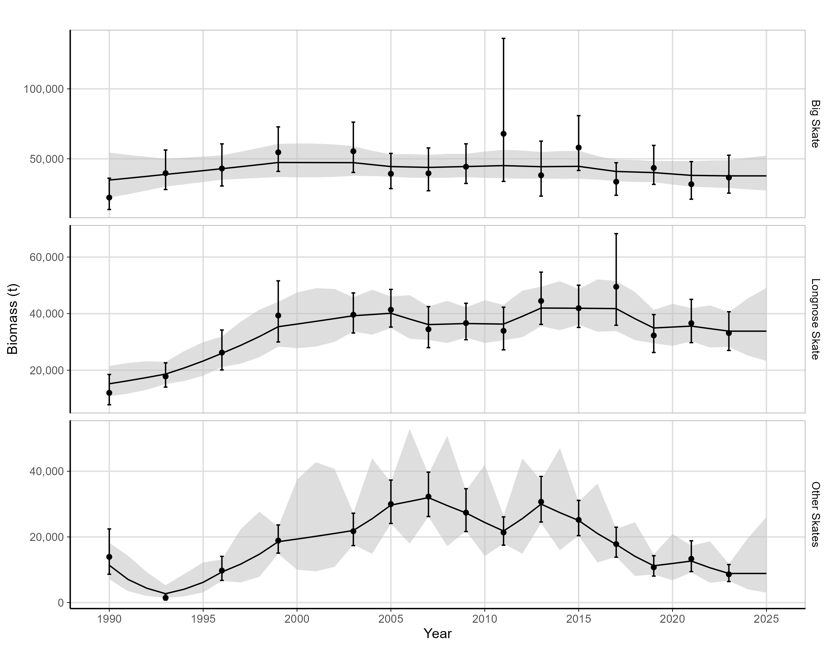

Figure 1: Biomass estimates (t) for Big skates (top), Longnose skates (middle), and Other skates (bottom) in the Gulf of Alaska between 1990-2025, from the AFSC bottom trawl survey (dots) and the random-effects model (RE) (black line). The grey shaded region is 95% confidence interval (in log-space) from the REMA model while the error bars are the 95% confidence interval (in log-space) from the survey. Note that vertical scales differ between the plots.

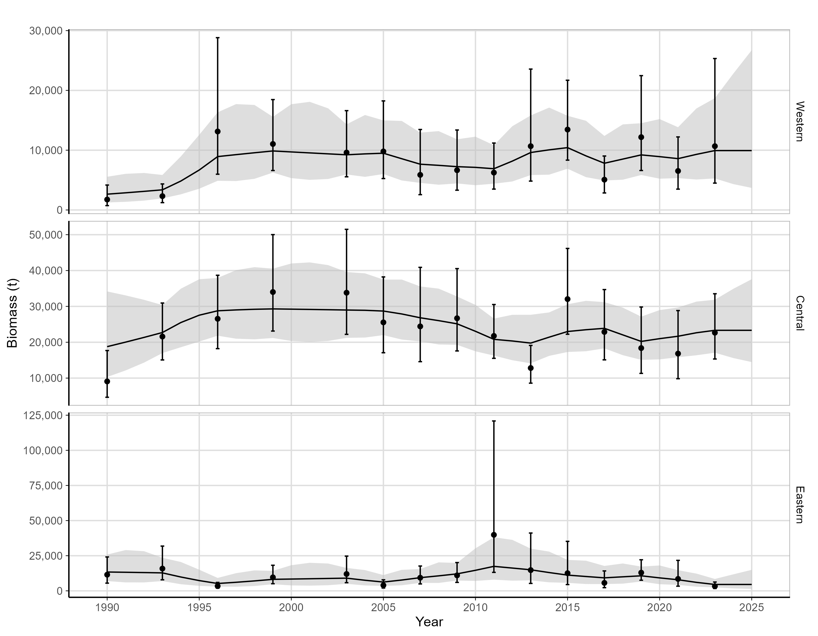

Figure 2: Biomass estimates (t) for Big skate in the three Gulf of Alaska regions from the AFSC bottom trawl survey (dots) and the proprotion in each area from the GOA-wide predicted Big skate biomass produced from the random effects model fitted to the survey time series (REMA model) (black line) from 1990-2025. The grey shaded region is 95% confidence interval (in log-space) calculated using values from REMA while the error bars are the 95% confidence interval (in log-space) from the survey. Note that vertical scales differ between the plots.

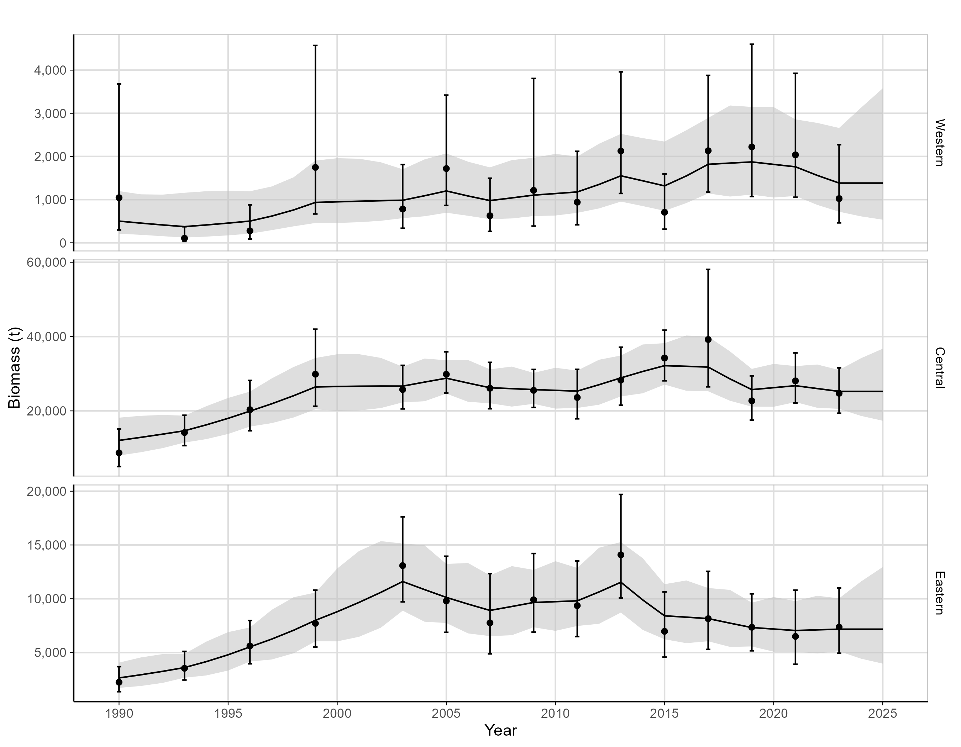

Figure 3: Biomass estimates (t) for Longnose skates in the three Gulf of Alaska regions from the AFSC bottom trawl survey (dots) and the proprotion in each area from the GOA-wide predicted Longnose skate biomass produced from the random effects model fitted to the survey time series (REMA model) (black line) from 1990-2025. The grey shaded region is 95% confidence interval (in log-space) calculated using values from REMA while the error bars are the 95% confidence interval (in log-space) from the survey. Note that vertical scales differ between the plots.

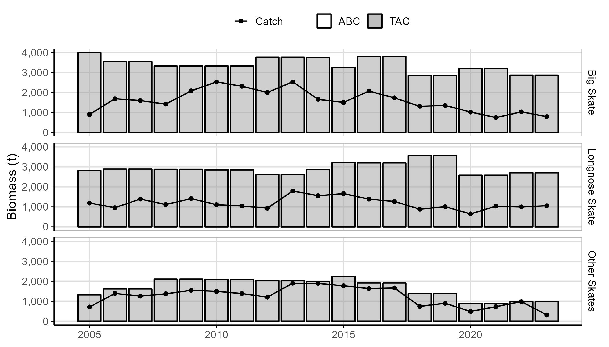

Figure 4: Catch, ABC and TAC for Big, Longnose and Other skates from 2005-2023. If the ABC is not visible, it means the TAC equals the ABC for that year.

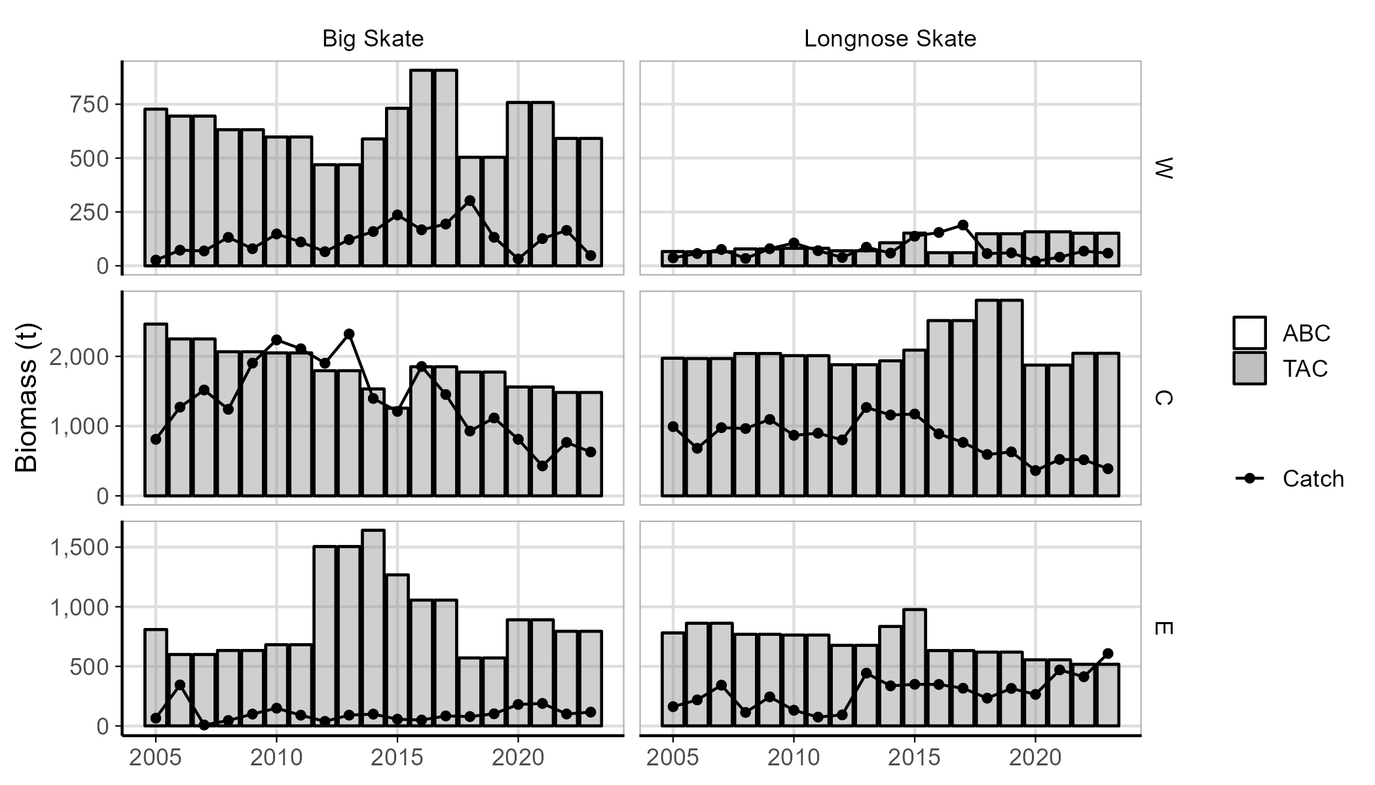

Figure 5: Catch, ABC and TAC in the three Gulf of Alaska regions (Western [W], Central [C], and Eastern [E]) for Big and Longnose skates from 2005-2023. If the ABC is not visible, it means the TAC equals the ABC for that year.

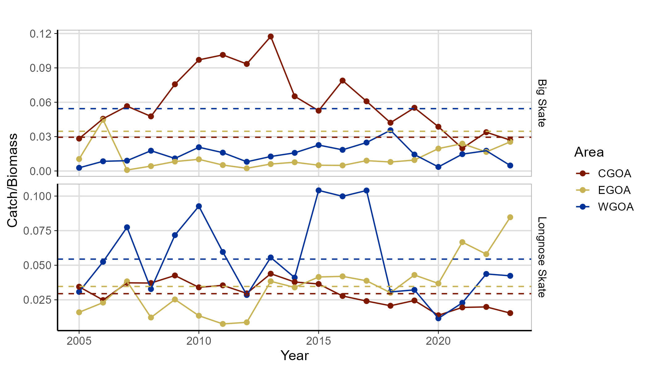

Figure 6: Exploitation rate in the three Gulf of Alaska regions (Western [WGOA], Central [CGOA], and Eastern [EGOA]) for Big and Longnose skates from 2005-2023. The dashed lines are the mean exploitation rates for the associated color.

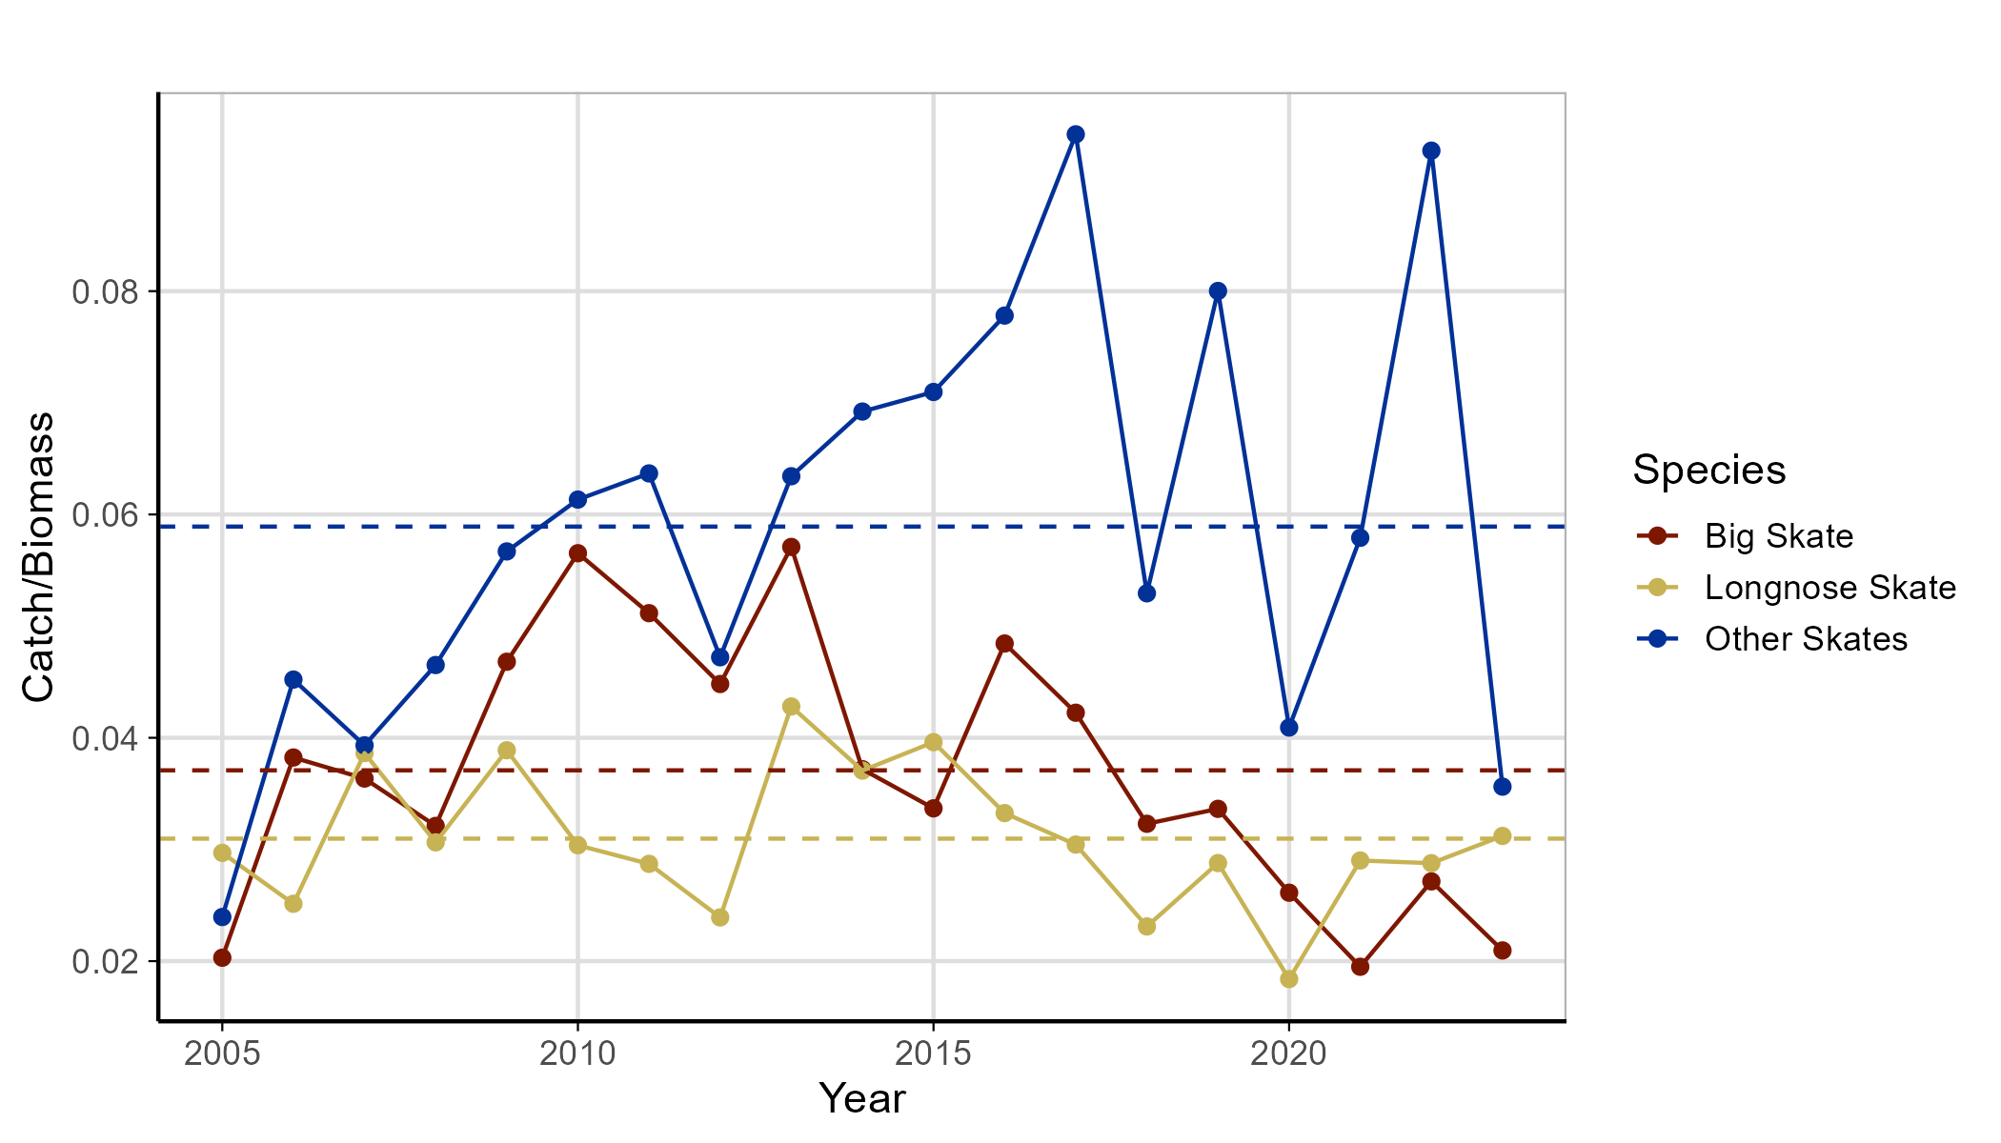

Figure 7: Gulf of Alaska wide exploitation rate for all three assessment groups (Big skate, Longose skate and Other skates) from 2005-2023. The dashed lines are the mean exploitation rates for the associated color.